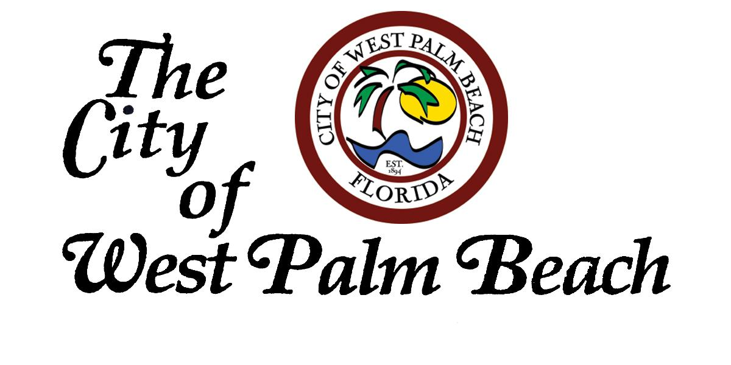

“The Capital City of the Palm Beaches”

Call to Artists
Request for Proposals
Neon Art on the Waterfront 2015 presented by
The City of West Palm Beach, Art in Public Places Program
Project: Temporary Installation opportunities at the Lake Pavilion on the waterfront June 2015
Budget: $2,000
Application Deadline: April 17, 2015, 5PM EST
Project Description:
The Art in Public Places Committee is seeking a wide range of art works for several temporary installation opportunities at the Lake Pavilion. Works submitted will explore and address the phenomena of neon light as an artistic medium. The artwork being sought includes, but is not limited to, light-based works, technology driven and inspired pieces, and interactive installations. Performance- based works, short films, animations and workshops will be considered. Not mandatory, but highly desirable are highly interactive works.
This call to artists coincides with the Art in Public Places Committee presentation of light and sculpture artist Jen Lewin’s interactive installation The Pool. The Pool will be on display at the Waterfront from June 4 through July 4, 2015. Coinciding with this installation the City of West Palm Beach is hosting a month long “Way to Glow WPB” a flurry of glowing activities.
Eligibility:
The project is open to all visual artists in South Florida.
Site opportunity:
Temporary installation at the Lake Pavilion 101 S. Flagler, West Palm Beach
Dates: Mon thru Wed. June 8-10, June 15- 17, and June 22 – 24
Artist will have an opportunity to present during one of these weeks.

Exhibition Promotion: Selected artists will be paid an honorarium of $500, inclusion in collateral, signage and media materials of The Pool and Neon Art in the Waterfront, invitation for opening night event for The Pool, full access and use of the site.
Submissions: Please submit the following to: scwelter@wpb.org
A complete submittal consists of the following:
- A written statement, as a PDF, no more than one page in length, describing your project, art work and/or performance
- A current resume (PDF) not to exceed two pages.
- 10 Digital images of Past work and if applicable Proposed work and/or project – JPG format
  - JPG format should not exceed 2MB Please do NOT submit TIFF, GIF, PDF, etc.)
  - ID sheet as a PDF - Number and label each image: title of work, medium, dimensions, and date of work - Not mandatory, but can be included is a maximum of two explanatory sentences about artwork/project - You may on this sheet add about to 5 links to Vimeo, Youtube, etc. Use the same format as above (title, medium, date)
Criteria for Selection: The Art in Public Places Committee will review completed submissions responding to this Call. The primary criteria for selection will be based on the following: Artistic merit in an artist body of work; Ability to design work that is relevant to the context/theme; Strong conceptual skills; Innovative and effective approaches to creative projects and the probability of successful execution and completion of the work/project.
For further information please contact: Sybille Welter, Art in Public Places Coordinator scwelter@wpb.org or 561.822.1521

