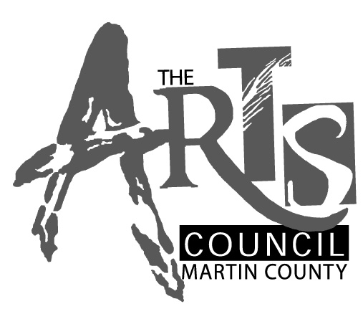
APPLY TO BE IN AN EXHIBITION
At the Court House Cultural Center Gallery
Artist Application Guidelines

Under the direction of the Arts Council of Martin County, the Court House Cultural Center (CHCC) hosts five art exhibits annually. The CHCC Gallery Committee is responsible for recommending a calendar and supporting the installation of exhibits.
Two shows are annual events: the Annual Juried show and the High School Juried Arts Show in May. In addition, every other year the schedule includes a curated new/emerging artist/art forms exhibit, which will be held again in FY 2013-2014 (Oct-Sept).
The calendar of shows is planned in advance; however, the Board approves a budget annually. Artist wishing to submit works for consideration are required to follow the Call to Artists instructions described below and to complete the attached application form.

GUIDELINES
The Gallery Committee selects a sub-committee of volunteers who review submitted works. Requirement for submissions are explained below. The members of this committee or their family members cannot be considered for an exhibition in the cycle that is being reviewed. The sub-committee’s recommendations are presented to the full CHCC Gallery Committee and then presented to the Arts Council’s Board of Directors for final approval.
Artists may remain on an approved list for up to 2 years. After two years, the approval expires if an exhibition including that artist has not been slated. Those artists will be invited to re-submit new works for consideration. The Arts Council, via the Gallery Committee, reserves curatorial approval of all exhibition content.
Annually, applications are accepted for review from September 1 to November 30. Applications arriving after November 30 will be returned to the artist. Incomplete applications will be returned to the artist with the option to resubmit a complete packet in advance of the November 30 deadline. The Subcommittee will review the work and make recommendations to the full Gallery Committee and subsequently to the Board within 60-75 days. Applicant artists will be notified following this period about their status.

APPLICATION DETAILS
Applicants will submit the following materials either by mail or hand-delivered to the Arts Council. The packet includes:
- One-Page CHCC Exhibition Application Form
- A 250-word (max) artist/curatorial statement (hard copy)
- A resume of up to two pages (hard copy)
- 10 (still) images of work on a CD; digital images should be presented as jpeg with a minimum 300dpi. Images should be representative of your current body of work.
  - Identify each image using Last Name, underscore (_) and the number corresponding to the image list (e.g.: Smith_01.jpeg)
  - Dimensions cannot exceed 1200 pixels wide or 800 pixels high.
  - Limit file size to less than 1 mb per image
  - Please limit video entries to (2) 3-minute segments
- List of images to include Title, Medium, Dimensions and year for each artwork (hard copy)
- Include a SASE for return of materials

Artists are eligible to apply as a group. The group curator must provide a statement describing the exhibition concept. In addition, each artist needs to provide a complete Artist Information packet (items noted above). The group curator must indicate if artists may be added or subtracted from the group’s application so that the review committee may know if they can score each individual artist or only consider a group score.

Incomplete or inaccurately assembled applications will not be considered. Notifications of acceptance or rejection will be sent by letter. Please update your contact information should there be any changes.

IMPORTANT DATES
September 1 – November 30
Applications are accepted.
December 1 – January 30
Applications are reviewed and recommended
February 1- February 28
Artists are notified of “accepted” or “non-accepted” status
April 1 – June 15
Shows are selected; artists are matched with shows and recommended to the Board for approval. After approval and artists’ acceptance to be a part of the proposed shows; artist agreements sent to artists for signature.

EXHIBITION CRITERIA and PURPOSE STATEMENT
From among the individual applicant artists, the Gallery Committee will combine artists that complement each other and/or are part of an overall theme. The appointed volunteer curators will work with artists who are chosen for a show in order to select and curate the exhibition. Among the types of exhibitions that may be considered:
- Invitational – introduces an artistic vision, particular art form or group while promoting and supporting its positive effect on community attitudes
- Retrospective – celebrates an artist’s life work and recognizes the artist’s contributions to the community through their art
- Multi-Artist Show – (2 or more) – brings together living, working Florida artists in complimentary collaboration, educates and exposes the community to new forms of artistic expression, and offers works of interest to private collectors. In very rare instances, a single artist exhibit may be considered.
- Private Collections – recognizes the support of the arts by an individual collector or collectors in the community and may ultimately inspire private and corporate collectors to participate in the culture of the region
- Concept Exhibitions – introduces a contemporary artistic vision or community initiative and focuses attention on its potential for positive growth and change in the community.

The Arts Council reserves the right to invite artists to be part of any of the above described shows as they are designated.

Questions? Contact the Arts Council, 287-6676 ext 11 for more information. The Gallery Committee meets on the 1st Tuesday of most months.

CHCC GALLERY ARTIST EXHITIBITION APPLICATION

Name:
Mailing Address (street, city state and zip):
Email Address:
Primary Media Category (select from drop down menu):
Artist/Curatorial Statement (250 words):

Checklist for Artist Packet:
One-Page CHCC Exhibition Application, including the Artist Statement
Resume (no more than 2 pages)
10 still images of work on CD or Video segments (max 2 @ 3 minute)
List of Images on above CD
Self-Addressed Stamped Envelope (SASE) for return of materials

FOR OFFICE USE ONLY
Date Application Received: __________________

Is Application Complete: ___ Yes or ___ No

Date Scheduled for Review: ____ / ____ / _____

Status: ___ Approved ____ Not Approved. Date Notified of Status: ____ / ____ / _____

Date for Exhibition: ____ / ____ / _____
Details (name other artists/theme, etc.): ______________________________________________

