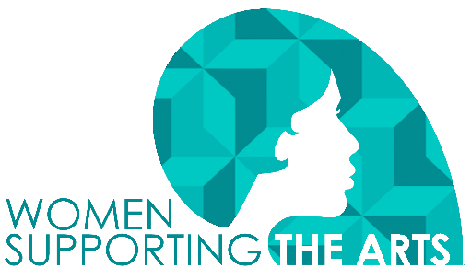
Guidelines and Tips for Completing a Grant Application

Eligibility
- WSA welcomes grant applications from organizations and/or individuals who want to enhance arts opportunities for Martin County artists and residents through programs, projects, scholarships, and internships. Collaborations among artists, organizations, and businesses are encouraged.
- All funding provided by WSA must be used to provide arts experiences within Martin County.
Assessment Criteria
In reviewing grant applications, the following criteria will be applied:
- The applicant must demonstrate the value of the program, project, event, scholarship, or internship to strengthen the arts environment in the Martin County community.
- As appropriate, the applicant should describe an effort to increase public awareness of and participation in the arts in Martin County.
- Applicants will benefit from demonstrating they have or will establish partnerships and collaborations with Martin County businesses, organizations, and other entities.
- If an applicant held a grant during the previous year and did not complete it or did not submit a report, the applicant will not be considered for funding in the coming year.
Funding Limitations
Please be aware that WSA rarely provides 100% of funding to any grant request. We encourage grantees to form collaborations, so the arts truly become part of the fabric of our community.
WSA does not provide grant funding for:
- Projects and programs retroactively
- Deficit reduction
- Religious or political purposes
- Operating support (e.g., space rental or equipment purchase for ongoing business operations)
- Private entertainment, food, and beverages
Selection of Grant Recipients
Women Supporting the Arts and its members are solely responsible for reviewing applications and selecting grantees.
Conditions of Funding
- As a prerequisite of funding, grant recipients agree to recognize MartinArts and Women Supporting the Arts on relevant materials, such as publicity materials and programs.
- Grants shall be used only for the purpose(s) outlined in the application. Changes in scale, activities, and timeframe must be reported promptly and negotiated for acceptability.
Completing the Application
We highly recommend composing your narrative in another program so you can save the question responses, then copy and paste them into the online form (see the QR code at the end of this guide). There is no option to save the online form and go back to finish later. Once you hit Submit, your application is complete, and you will receive an email with a copy of your application. This will confirm that you have completed the process.
- For tips on writing a strong narrative, see our Tips document, available in the WSA section of the MartinArts website (or see the QR code at the end of this guide).
- The preferred format for attachments is PDF, which helps to ensure that grant reviewers can access and rate your application. If we can’t read it, we probably won’t fund it.
- The application requires use of our grant budget form. There are some basic instructions on the form itself. You will be required to upload the budget form with your application.
Tips for completing your budget:
- In-Kind Expenses and Income should match. They essentially "wash each other out” on the budget form but often represent important donated services or products that make a project work. List only items that you would have purchased if the donation weren't available, which is why it shows on both the income and expense budget. For example, a local business donates clay to use in a ceramics project. The expense is listed in COLUMN C Other A (Fill in Project Supplies or Clay, if you prefer) and again in Column C on the income side under Corporate Support.
- You can have expenses and income in the same line in both the expense and the income budget. You may want to split a cost across columns. For example, you have a donation of some supplies for a project but not 100% of what you need, so you are including it in your grant, too. The appropriate amounts would show in the same line of the budget but in both columns (or all three if that is the case). In this case, on the income side, the donation would show on the appropriate line related to the source of the donation, but the portion that is a part of the grant request will only be reflected in the Grant Amount Requested box.
- Keep it simple. Provide any clarifications or expansions in the grant application under Budget Narrative. You can explain anything you think our members may question when reviewing the grant.
- The most important part of this is to let the Excel spreadsheet do the math for the columns and the totals for you. Formulas have been built into the budget file, so you don’t need to do that. The total project budget and total project revenue boxes should be the same amount when you finish your budget. You may have excess income you aren't reporting but that just means you've been successful in recruiting sponsors or ticket buyers if it’s that kind of project. This budget isn't designed to capture that.
File Your Grant Report
Every grantee must report on project progress or completion by August 15 of the grant year. You should use the online form in the WSA section of the MartinArts website. As you did with the application, you may want to prepare your responses in a separate file, then copy and paste them into the online form.
Find the Online Tips and Forms
Go to the MartinArts website to get the tips for writing your narrative and the online forms for the grant application, budget, and August report. Use this link or scan the QR code below to find the forms.
[insert QR code]

Need Help?
If you have questions about any part of the application process, please call or email Nancy Turrell, 772-287-6676 ext. 4 or nancy.turrell@martinartsfoundation.org or Allison Shepard, 772-287-6676 ext. 6 or ashepard@martinarts.org.

