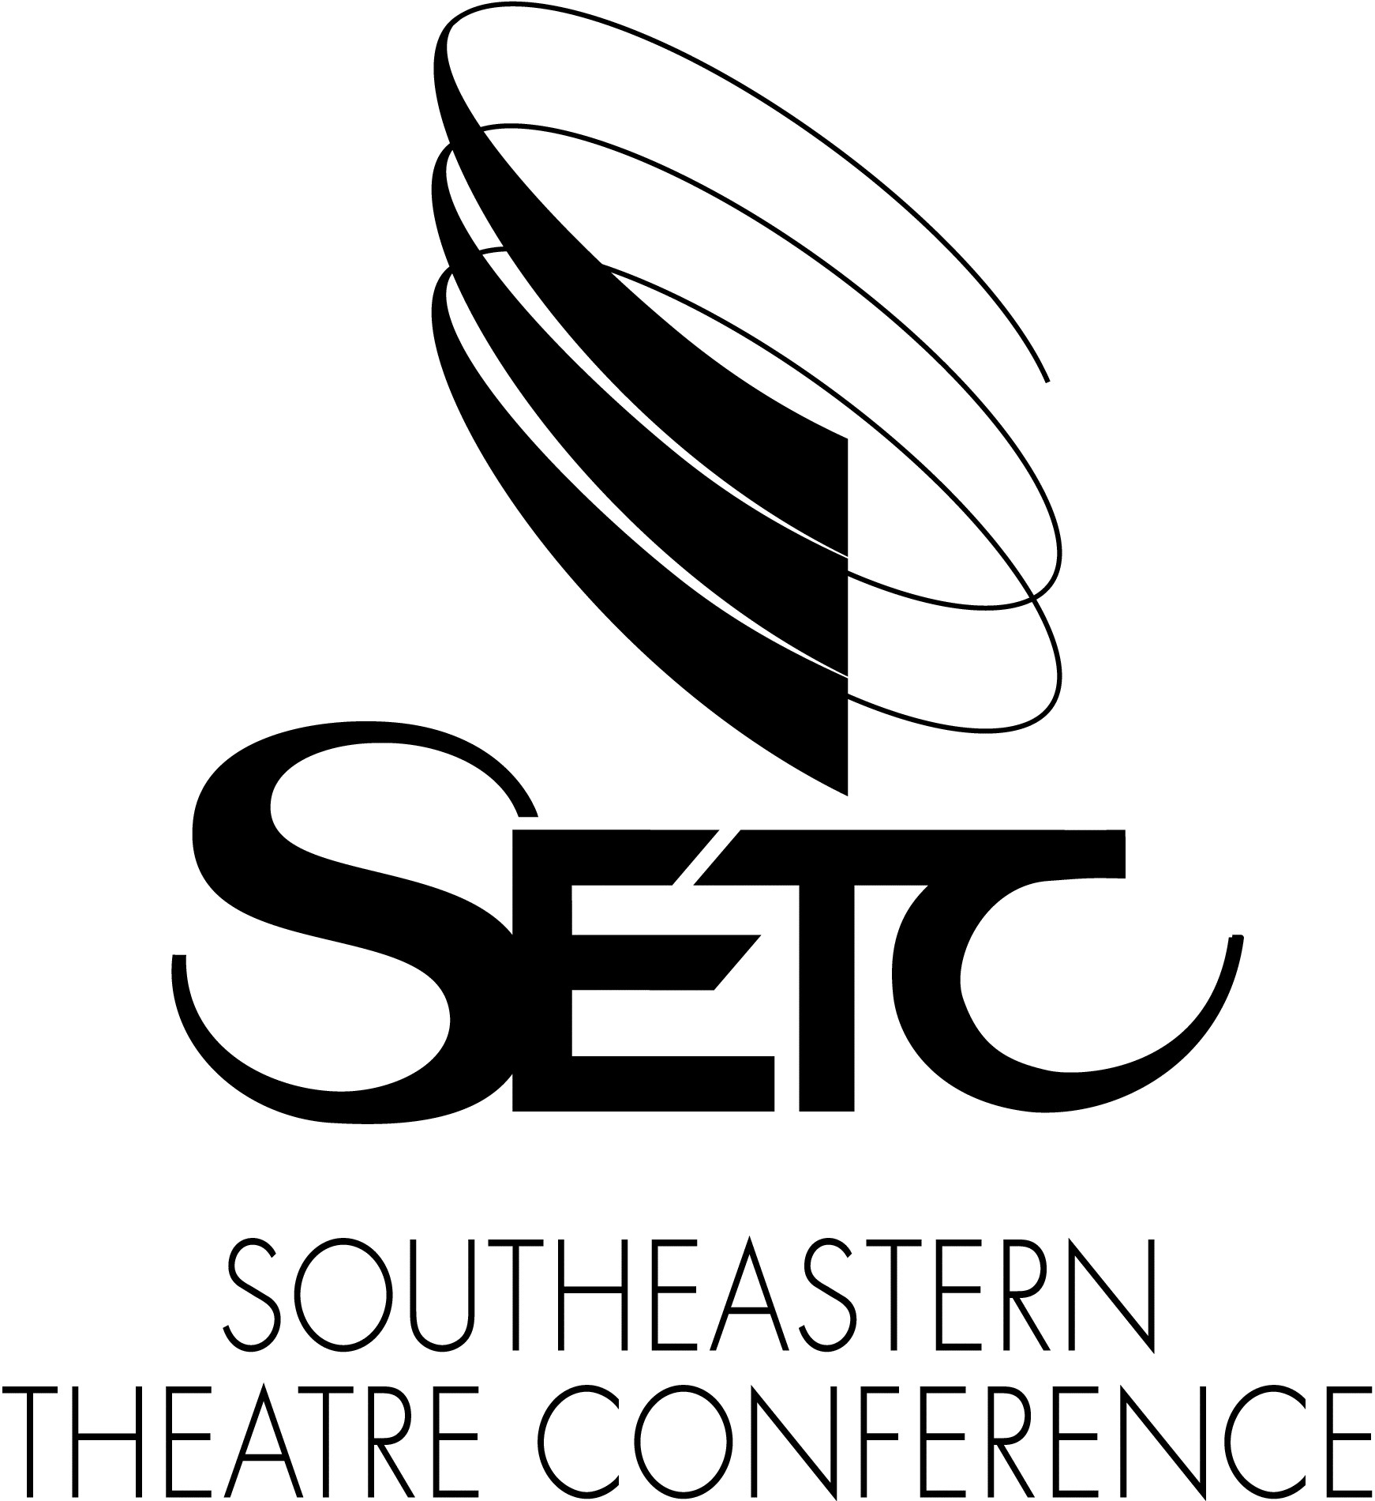
FOR IMMEDIATE RELEASE: 6/14/19
Event Dates: 8/24/19 – 8/26/19

Clay Thornton
Southeastern Theatre Conference (SETC)
Connecting You to Opportunities in Theatre Nationwide
336-272-3645
clay@setc.org

Southeastern Theatre Conference Conducts Fall Professional Unified Auditions
SETC’s annual fall professional auditions are held in Charlotte, NC again this year with the event dates of Aug. 24th and 26th. Registration for both participating companies and actors opens June 14, 2019.

Charlotte, NC: Southeastern Theatre Conference (SETC) is excited to announce that the annual SETC Fall Professional Unified Auditions are taking place at the Sheraton Charlotte Hotel (uptown) on August 24 -26, 2019.

Hiring companies and actors from across the country will convene for auditions and callbacks working to fill quality roles for a variety of theatres and venues. Theatre types represented include repertory, regional and stock companies, single show venues, cruise lines, dinner theatres, entertainment agencies, seasonal shows and more. This annual event has become a primary place for connecting professional actors in theatre to opportunities in the theatre and entertainment industries.

Referring to this year’s event, SETC’s Auditions Director April Marshall stated, “These auditions can be viewed as casting for fall and holiday seasons as well as getting a head start on casting for spring, summer and year-round seasons for 2020. This year our goal is to continue our tradition of providing quality companies and matching them with dynamic applicants. This event is all about actors getting the best jobs and companies filling their needed roles.”

SETC Fall Professional Unified Auditions by the numbers:
* Participating companies looked to fill over 2,100 roles at the 2018 auditions
* Each year multiple theatre companies and casting representatives participate
* An annual average of 200 actors, singers and dancers audition

Registration for the event is open as of June 14, 2019 and can be completed online via SETC’s website at this link: https://www.setc.org/auditions/fall-professional/ or you can contact us by email or phone with questions at info@setc.org or 336-272-3645.

SETC is the strongest and broadest network of theatre practitioners in the United States and provides extensive resources and year-round opportunities for its constituents. Our services, publications, and products contribute significantly to the careers of emerging artists, seasoned professionals and academicians. SETC energizes the practical, intellectual and creative profile of theatre in America.

###

